Responsibilities in Action: Massachusetts MAP Certification Training

Are You Ready for Online Learning?

What Technology do I Need to Take This Course?
- A strong internet connection and a device that will connect to the internet.
  - We recommend that you update your internet browser. This course works best on Firefox, Chrome, Edge and Safari.
  - This course was designed to run best on computers or laptops, but it can also be completed on a tablet or smartphone using the device’s internet browser.
  - The course can also be completed on a mobile app with a tablet or smart phone by downloading and installing the Moodle app. Be aware that some issues have been reported on the Moodle app with missing images, difficulty enlarging knowledge checks, difficulty using “drag and drop” features on knowledge checks, and difficulty with ReadSpeaker and other accessibility tools. These issues have not been reported when using the device’s web browser (Safari or Chrome).
- A camera on your phone, tablet, or computer that will allow you to take video and upload it through the internet, as well as participate in virtual video meetings.
- If you choose to complete the video assignment using YouTube, you will need a YouTube account. This assignment can also be completed through a live virtual session with your Trainer or by uploading the video to a different file sharing site like Google Docs/Photos or Vimeo.
- If you have technical questions during the course, that cannot be troubleshooted by your MAP Trainer or Service Provider, please contact CDDER@umassmed.edu
- If you have questions about the course content, please contact your MAP Trainer.

How Do I Find the Course Online?
- Access the course here: https://mapmass.com/
- The course you are taking is Responsibilities in Action: MAP Certification Training.

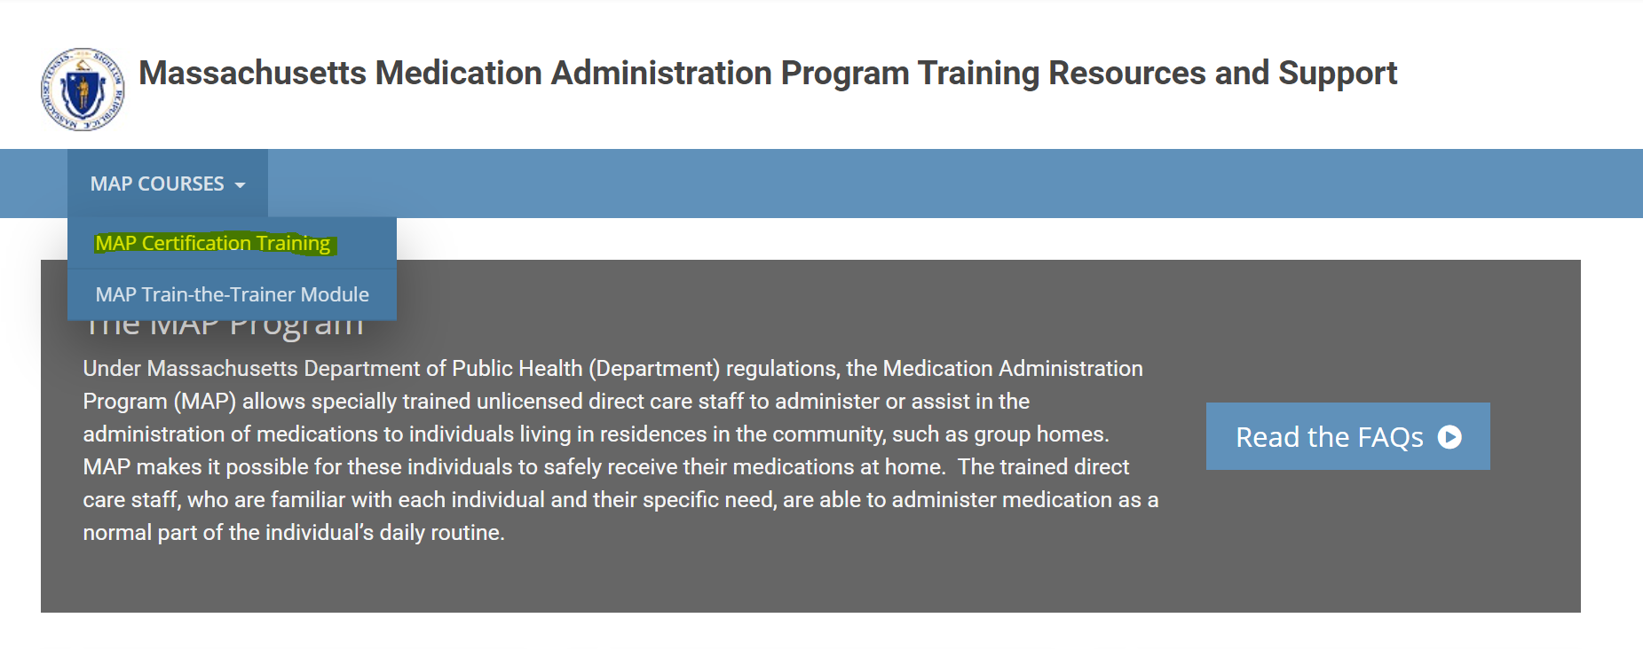

How Do I Log In?
Once you’ve found the course, you will need to log in.
- You should have received an email from Admin User (via Massachusetts Medication Administration Program Training Resources and Support) <noreply@neindex.org> with your unique username and temporary password. If you don’t have that e-mail, check your spam folder. If you still don’t have it, email: CDDER@umassmed.edu
- Enter your username and temporary password to gain access to the course.
  - Make sure the email address you use for the course is one that is up to date and that you check regularly.
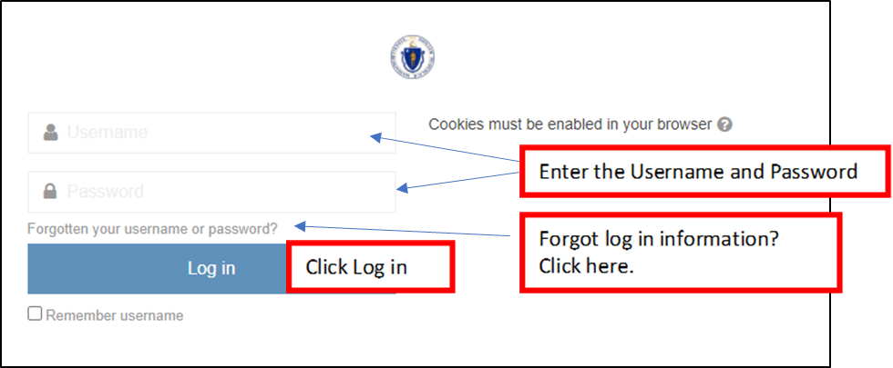
- You’ll be prompted to change your password the first time you log in.
  - Once you’ve successfully done this, you can access the course using your username and new password whenever you log in. If you forget your password, you can use the ‘Forgotten your username or password” link if you’ve logged in at least once.

How Long Will It Take to Complete the Online Course?
- This course has 9 units as well as several skills activities to complete. You must pass a quiz at the end of a unit with a score of 80% or higher to move to the next unit.
- The average time to complete the 9 units and 9 quizzes is 13 – 14 hours. This does not include time spent reading the RIA curriculum, making your medication demonstration video, or practicing Transcription. Plan for at least 16 hours to complete the course.
- Units 1-5 are less time consuming than Units 6-9, which are longer, and will require more interaction as they are teaching skills.
- Pace yourself to allow more time for the last 4 units.

