Responsibilities in Action: Massachusetts MAP Certification Training

Are You Ready for Online Learning?

What Technology do I Need to Take This Course?
- A computer or laptop with an internet connection.
  - We recommend that you update your internet browser. This course works best on Firefox, Chrome, and Safari. This course has not been fully tested yet in the new browser, Edge.
  - This course was designed to run optimally on computers or laptops. The course can also be completed on a mobile app with a tablet or smart phone. Some issues have been reported on the Moodle app with missing images and difficulty enlarging knowledge checks. If using a tablet or phone, we recommend accessing the course through the web browser (Safari or Chrome).
- A camera on your phone, tablet, or computer that will allow you to take video and upload it through the internet, as well as participate in WebEx or Zoom video meetings.
- If you choose to complete the video assignment using YouTube, you will need a YouTube account. This assignment can also be completed through a live virtual session with your Trainer or by uploading the video to a different file sharing site like Google Docs/Photos or Vimeo.
- If you have technical questions during the course, that cannot be troubleshooted by your MAP Trainer or Service Provider, please contact CDDER@umassmed.edu
- If you have questions about the course content, please contact your MAP Trainer.

How Do I Find the Course Online?
- Access the course here: https://mapmass.com/
- The course you are taking is Responsibilities in Action: MAP Certification Training.

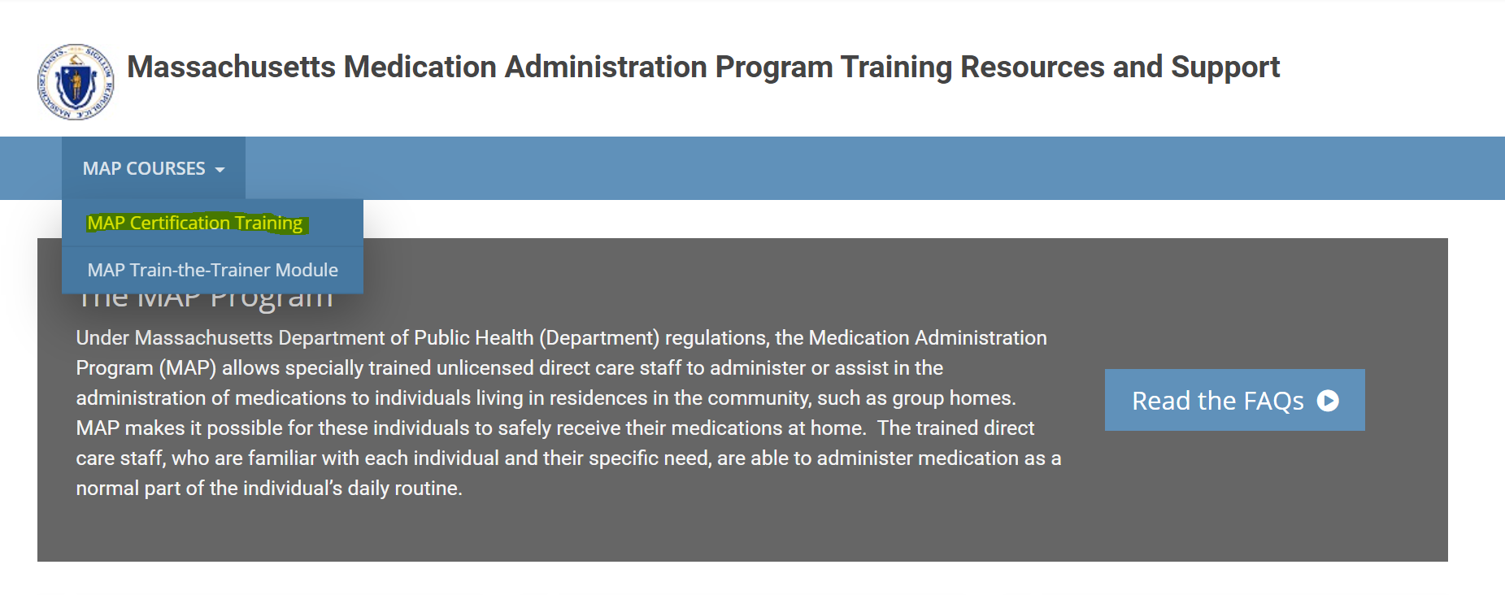

How Do I Log In?
Once you’ve found the course, you will need to log in.
- You should have received an email from Admin User (via Massachusetts Medication Administration Program Training Resources and Support) <noreply@neindex.org> with your unique username and temporary password. If you don’t have that e-mail, check your spam folder. If you still don’t have it, email: CDDER@umassmed.edu
- Enter your user name and temporary password to gain access to the course.
  - Make sure the email address you use for the course is one that is up to date and that you check regularly.
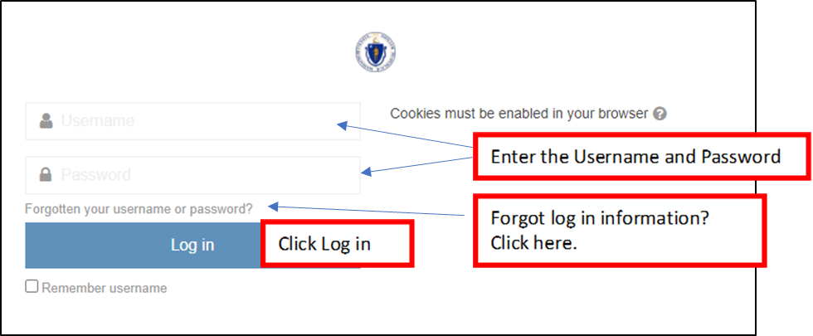
- You’ll be prompted to change your password the first time you log in, which you must do.
  - Once you’ve successfully done this, you can access the course using your username and new password whenever you log in.

How Long Will It Take to Complete the Online Course?
- This course has 9 units as well as several skills activities to complete. You must pass a quiz at the end of a unit with a score of 80% or higher to move to the next unit.
- The average time to complete the 9 units and 9 quizzes is 13 – 14 hours. This does not include time spent reading the RIA curriculum, making your medication demonstration video, or practicing Transcription. Plan for at least 16 hours to complete the course.
- Units 1-5 are less time consuming than Units 6-9, which are longer, and will require more interaction as they are teaching skills.
- Pace yourself to allow more time for the last 4 units.

